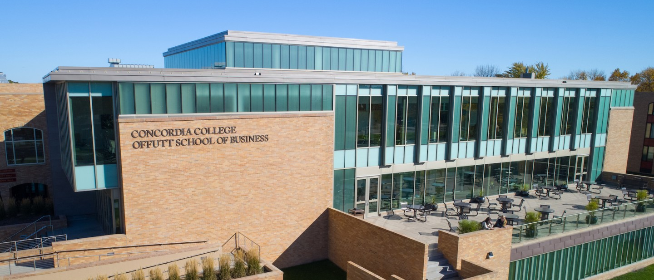

Cobber Chat

**CSC 345 – Fall 2020**

Course Name

**GSSK**

**Team Name**

**Team Member 1 – Kinsey Younggren  
Team Member 2 – Shristi Chapagain  
Team Member 3 –** **Gansaikhan Shur  
Team Member 4 – Sachin Karki**

**Team Members**

This project is for someone to talk to someone else that has a computer that does not want to use or sign up for big companies. This is for anyone that would want to use it. Some people might like it better than other messaging platforms because it is simple, and has low traffic of people.

**Synopsis**

Cobber Chat is going to be a messaging platform where one person can talk to another on a different computer. Cobber Chat is going to allow people to communicate with each other on a low traffic platform, as well as it will be a challenging project for our group which would allow us to learn about computer networks in depth. Anyone could beifit from this project

**Purpose**

Executive Summary

# Background

Many Messaging platforms are high traffic areas and could crash with making this messaging platform it has fewer people using it so it is low traffic. Also, this helps us understand networking better and we could talk back and forth on something we made. With others it would be somewhere where they can talk to their friends for fun.

**Problem**

# Project Plan

* Milestone 1: get group together and make a contract.
  + Completed
* Milestone 2: Figure out what final project is going to be and plan it out.
  + Completed.
* Milestone 3: Make a sketch of what the project is going to look like on the computer and how it is going to work together.
  + Completed
* Milestone 4: Have a good start on the project.
  + Completed
* Milestone 5: Figure out what is left of the project and dived up the work among us and continue working.
  + Deadline: October 29
* Milestone 6: Close to a little more than halfway done.
  + Deadline: November 16
* Milestone 7: Have the final project and presentation done.
  + Deadline: December 9

**Milestone Summary**

* Milestone 1
  + Team lead: Shristi
  + Worked on making a group contract and see when we are all available for team meetings
  + Meetings on Monday at 2
  + Assigned people for team leads for each milestone
  + Completed: September 10
* Milestone 2
  + Team lead: Kinsey Younggren
  + Figured out final project
  + Made a Network Topology Diagram
    - By:Gansaikhan Shur

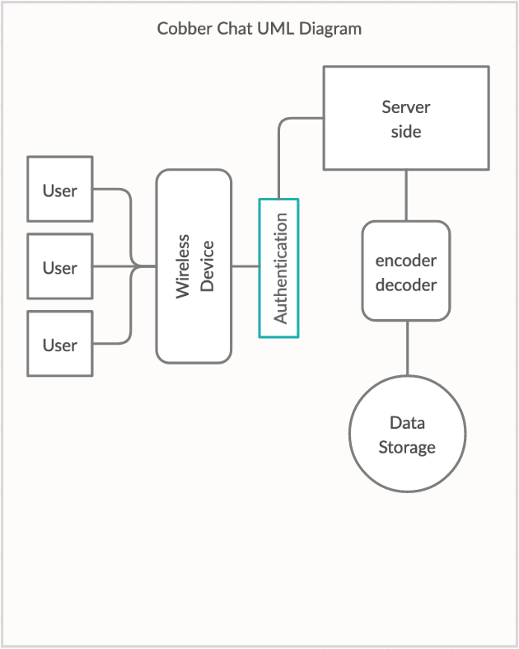

**Milestone 1 and 2 Details** With others it would be  somewhere where they can talk to their  friends for fun.**ls**

* Milestone 3
  + Team Lead: Khan
  + Designed and Sketched our website and how the data storage and retrieval part would work.
  + Kinsey

You would have a list of your friends in your home page and would be able to click on then to send them a text

**Milestone 3 Details** With others it would be  somewhere where they can talk to their  friends for fun.**ls**

* Milestone 3
  + Shristi

A Settings page where you would be able to change your username, passwords, etc

**Milestone 3 Details** With others it would be  somewhere where they can talk to their  friends for fun.**ls**

* Milestone 3
  + Sachin

A log in page

* + Khan

**Milestone 3 Details** With others it would be  somewhere where they can talk to their  friends for fun.**ls**

* Milestone 3

A sample Json format

**Milestone 3 Details** With others it would be  somewhere where they can talk to their  friends for fun.**ls**

* Milestone 3

A sample database table

# Project Resources

|  |  |  |
| --- | --- | --- |
| Date | Name/URL | Note |
| 9/27/2020 | https://docs.oracle.com/cd/E19263-01/817-6440/topology.html | Helped on the topology diagram. |